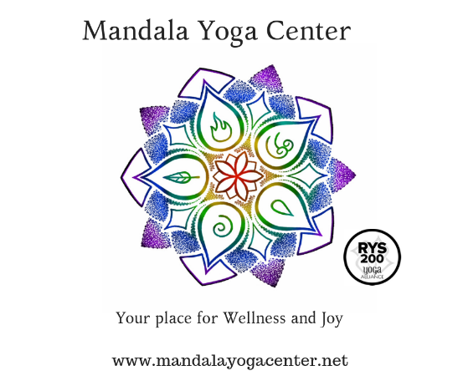
Teacher Training Application

I am applying for:
- 200-Hour Teacher Training Program
- 300-Hour Teacher Training Program

Name:
First Name___________________ Middle Name_______________
Last Name_____________________
Address:
Street Address_______________________________________
City____________________________________, State____ Zip code_____________
Same as mailing address?
- Yes
- No
If No – complete mailing address below
Mailing Address:
Street Address_______________________________________
City____________________________________, State____ Zip code_____________
Phone(s)
Cell _________________ Home _________________ work ___________________
Date of Birth ___________________
Email address ___________________________________
Emergency Contact Name:
First name __________________ Last Name ______________________
Relationship _____________________ Phone________________________
Email _______________________________________

How did you learn about the Mandala Yoga Center Teacher training program?
________________________________________________________________
________________________________________________________________
________________________________________________________________
How long have you been practicing yoga?
________________________________________________________________
How did you begin your practice of yoga?
________________________________________________________________
________________________________________________________________
________________________________________________________________
List your primary instructors, past and present:
________________________________________________________________
________________________________________________________________
________________________________________________________________
How often do you attend yoga classes outside of your personal practice?
________________________________________________________________
Describe your personal practice, if any: how often, time you dedicate to the practice, nature of the practice (what do you practice?), aspects of the practice, asana, meditation, pranayama…
________________________________________________________________
________________________________________________________________
________________________________________________________________
________________________________________________________________
Do you have any physical limitations or injuries? – Describe here:
________________________________________________________________
________________________________________________________________
________________________________________________________________
________________________________________________________________

Do you have a health care practitioner you see for the above or other conditions not noted here? Please describe:
________________________________________________________________
________________________________________________________________
________________________________________________________________
Why do you practice Yoga? What has it done for you?
________________________________________________________________
________________________________________________________________
________________________________________________________________
________________________________________________________________

Share your reasons for requesting enrollment into this program?
________________________________________________________________
________________________________________________________________
________________________________________________________________
________________________________________________________________
________________________________________________________________
If you are a 200-Hour yoga teacher or graduate of another yoga training school please share the details below:
Name and location of school – and hours of study
________________________________________________________________
___________________________________________________________
Date of graduation or completion; ________________________________________________________________

Name and phone number of primary contact at that school
________________________________________________________________
________________________________________________________________

If you currently teach Yoga or have taught yoga in the past please answer the following:
Where do you, or did you, teach yoga?
________________________________________________________________
________________________________________________________________
How long have you been teaching?
________________________________________________________________
________________________________________________________________

How many classes and hours a week do you teach? Describe the style of yoga you teach.
________________________________________________________________
________________________________________________________________
________________________________________________________________
Are you Yoga Alliance RYT (registered yoga teacher? DO you have other designations? Please list them.
________________________________________________________________
________________________________________________________________
Please acknowledge your understanding of the following statements:
- I understand that acceptance into the Mandala Yoga Center training program is contingent on a personal interview with the Director of the program and that I am responsible for calling Mandala Yoga Center to arrange for this interview. 910-325-3600
- I understand that the application includes a non-refundable application fee of $25 regardless of whether the application is accepted or interview is scheduled.
Total application fee:
$25.00
Please check how you would like to pay the non-refundable application fee.
- Online – Select Yoga training application fee
- Instore purchase
- I have pre-paid the application fee already at Mandala Yoga center.
Please acknowledge you have read the following:
- Overview and schedule of classes including guidelines for attendance, policies and requirements.

Signed
________________________________________________________________

Printed Name
________________________________________________________________

Date
________________________________________________________________

